Provo City Center Temple

Address

50 South University Ave

Provo UT 84601

United States

Telephone

(1) 801-343-2700

Services

Clothing rental available

No cafeteria available

No patron housing available

Distribution center nearby

2019 Closures

Sunday, 23 June 2019 - Saturday, 6 July 2019

Wednesday, 24 July 2019

Saturday, 5 October 2019

Wednesday, 27 November 2019 (Limited Hours)

Thursday, 28 November 2019

Sunday, 1 December 2019 - Saturday, 14 December 2019

Tuesday, 24 December 2019 - Wednesday, 25 December 2019

Tuesday, 31 December 2019

2020 Closures

Wednesday, 1 January 2020

Milestones

1 October 2011 Announced

12 May 2012 Groundbreaking

20 March 2016 Dedicated — dedicatory prayer

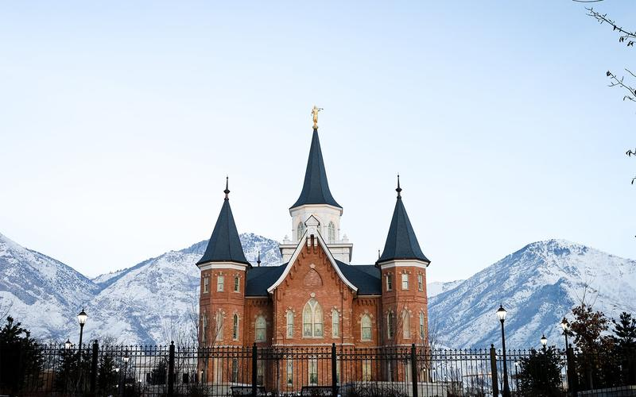

Reference: https://www.lds.org/temples/details/provo-city-center-temple?lang=eng